

Title: Online Flight Reservation System

Course ID and Name: BIC3254d Web Programming

Instructor Name: Niaz Makhdum

Date of Submission: 17.04.2025

|  |  |
| --- | --- |
| Name | ID |
| Zubair Mehdee | 1702400125 |
| Mohammad Bin Ghulam Hossain | 1702400165 |
| Rifatul Islam | 1702300089 |

# **Airlines Reservation System Development Plan**

## **1. Project Overview**

We have developed a web-based Airlines Reservation System using **XAMPP (Apache, MySQL, PHP)** for the backend and **HTML, CSS, JavaScript** for the frontend.

The application will allow users to book flights and allow admins to new register flights. A user can select the route and date and be shown the available flights. An admin manages the available flights and

### **Key Features:**

* User registration & authentication (Admin & Customer)
* Flight search & booking
* Seat selection & payment processing
* Booking management (view/cancel)
* Airlines Management
* Simple Payment System(non-functional)
* Admin dashboard (flight & user management)

## **2. Development Stack**

|  |  |
| --- | --- |
| **Component** | **Technology** |
| **Frontend** | HTML, CSS, JavaScript |
| **Backend** | PHP |
| **Database** | MySQL (via XAMPP) |
| **Server** | Apache (XAMPP) |
| **IDE** | VS Code |

## **3. Web Application**

This Online Flight Booking System Project in PHP focuses mainly on booking airline tickets. To be more precise, the system helps to keep track of the flight schedule, and their management. Also, the system displays all the round trips and one-way routes. In addition, the system allows setting up cities too(codeastro.com). Evidently, this project contains an admin panel and a simple client-side. In an overview of this web application, the user can simply register in order to use the features. Here, passengers can search for the flight details. For this, the passenger has to select departure and arrival location with dates, class, and number of passengers. As a result, the system filters out available flight schedules with detailed information.

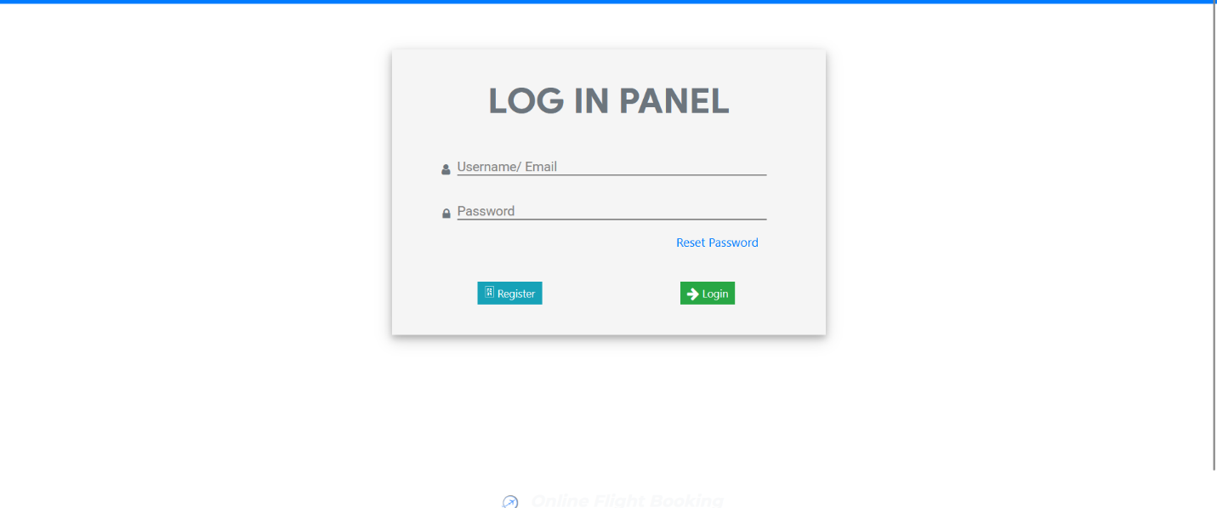

**Booking Airline Tickets**

This whole passenger side of thing works from the client-side. For booking a flight ticket, the passenger must select any of the available results. After, the system asks for the passenger’s details such as name, contact, email, and date of birth. The final step of booking an airline ticket includes payment where they have to enter card information. And after a successful transaction, the user can view their tickets from the tickets section. All the tickets are automatically generated by the system after bookings. In fact, the ticket contains all the flight information such as names of airlines, locations, boarding time, seat, gate number, etc.

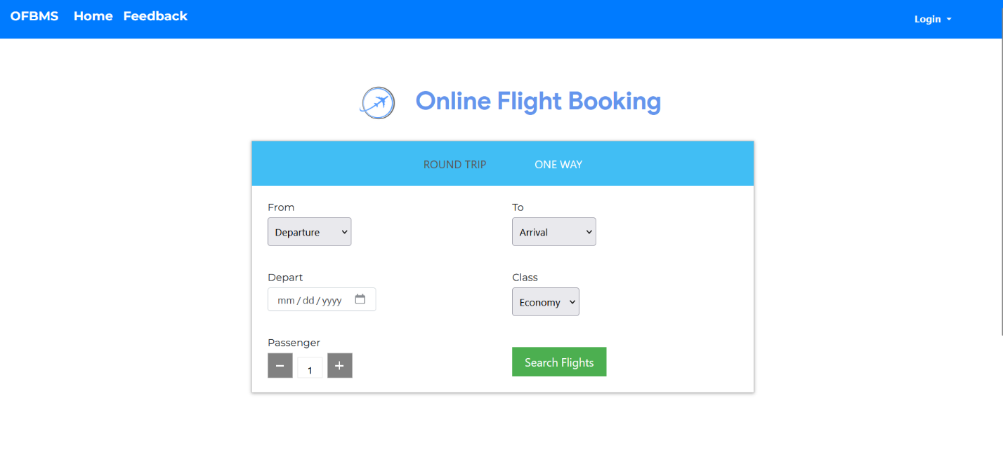

**Admin Panel**

An administrator has full control over the system. They can manage flights, cities, and so on. Here, every section has its own respective details such as name, and other important details.. The record of today’s flight, departed-arrived flights, and flight issues are shown in the admin panes. In terms of flight management, the admin can manage flights of the current date and time. Speaking of flight management, the admin can make sure to mark flights as departed and mark as arrived looking at their status. Additionally, the user can also mark the issues of flight if any.

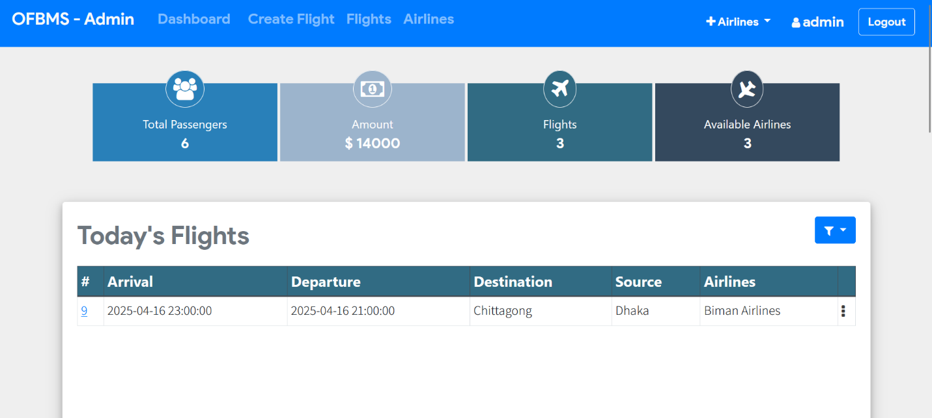

**Flight Management System**

Moreover, the first step in managing flight details is to set up airlines and city locations. Then, the administrator can simply proceed with the management of the flights. All the schedules arranged by the administrator are the ones that end-users interact with for their online airline ticket reservations. Regarding flight schedules, the admin has to provide a number of details. That includes departure and arrival date-time with a selection of departure and arrival locations, duration, price, and airlines. In fact, the administrator can simply remove the flight and airline records anytime. All these airlines along with location details are mandatory for flight schedule management. In addition to it, the admin can only control the current date’s flights from the dashboard. The administrator can view the total number of passengers on each flight with detailed information.

Also, the system prevents users from booking without logging into the system. The system does not allow booking flights that have been departed. A clean and simple dashboard is presented with various color combinations for a greater user experience while using this Online Flight Reservation System Project in PHP MySQL. For its UI elements, a free open-source CSS framework; Bootstrap is on board with some Vanilla CSS too. Presenting a new Online Flight Reservation System Project in PHP MySQL which includes an admin panel. 